Name  Write your own name. Lv refers to your age, but feel free to be dishonest.  Delete the blue boxes | Lv.

Class 1- No( ) Name( )
めあて：

You can make your own radial graph in excel, or online here https://www.onlinecharttool.com/graph for free.

Delete the blue boxes
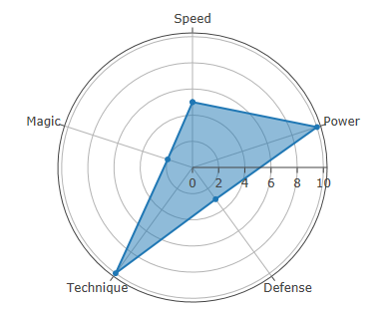
Make your own avatar for free at https://avatarmaker.com/

Delete the blue boxes

メモ：
Questions 質問 |  | Answers 答え

動詞 | カテゴリー
like  好き | sport(スポッツ) | food(食べ物) |  |  | anime(アニメ) |  | game(ゲーム) |  |  | subject(教科)
play  する | sport(スポッツ) |  |  | musical instrument(楽器) |  |  |  | game(ゲーム)
study  勉強する | subject(教科)
have  持つ | sister(妹・姉) |  | brother(弟・兄) |  |  | pet(ペット) |  |  | thing(物)
watch  見る | movie(映画) | anime(アニメ) |  |  | TV program(テレビ番組) |  |  | Youtuber(ユーチューバー)
read  読む | book(本) | manga(マンガ)

Level 1質問
Do you (動詞) (カテゴリー)?
例えば： Do you (like) (games)?
Do you (like) (Dragon Quest)?

Level 2質問
What (カテゴリ) do you (動詞)?
例えば： What (anime) do you (watch)?

