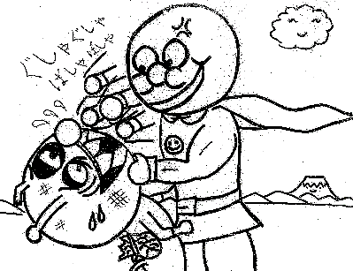
Warming up
Class( ) no( ) Name:
めあて：
例 | ○○ looks ~. | Anpanman looks happy.
1 | 1. Divide the chalkboard into 3-4 sections. Make the same number of teams out of the class. In pairs the students go to the chalkboard. You say a sentence like, “Snoopy looks cold.” The students at the chalkboard have 1 minute to draw that. All the other students write the sentence on their sheets. After time is up check as a class. Award points to each drawing based on how well it represents the sentence. JTE may pick one group to give a bonus point to.  Delete this blue box before you print (duh)
2
3
4
5

~ at the park
A | ○○ enjoyed 動詞ing形 at the park.  ○○ didn’t enjoy動詞ing形 at the park. | Rules: | - You can use any pattern of ABC.  - You must write English and Japanese.  - It must look true.
B | ○○ likes 動詞ing形 at the park.  ○○ doesn’t like動詞ing形 at the park. | Rules:
C | ○○ started 動詞ing形 at the park.  ○○ finished動詞ing形 at the park. | Rules:

英語
Before class I print off one copy of the characters picture. Then I write numbers next to some characters, 1-11, or you can also write next to two characters, so then there would be 2 characters with each number. Then you can either make a copy for each group OR make a large copy to hang in the front of the classroom.

Delete this blue box before you print (duh)
日本語

英語
日本語

英語
日本語

英語
日本語

英語
日本語

英語
日本語

英語
日本語

英語
日本語

英語
日本語

英語
日本語

英語
日本語

