
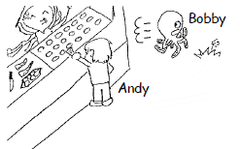
めあて：
- Read the question.
- Find the characters.
- Write the answer.
- Check with a teacher.
Question: | What was Bobby doing when Andy bought takoyaki?
When 主語1 過去形 , |  | 主語２ be動詞の過去形 動詞ing形
When Andy bought takoyaki, |  | Bobby was running.
動詞list:
buy, watch, kick, play, take, eat, dig, use, cook,
sleep, run, walk, throw, drink, ride, go, swim, listen, sing, hold

What was John doing when Marry and Baikinman played soccer?
When they played soccer, John was ________ing them.

What was Tom doing when Joy sang a song?

What was Mike doing when Kuma-tan ate Anpanman?

What was Zura doing when Koki went swimming?

What was Julia doing when Satoshi threw a monsterball?

What was Alex doing when Bertolt became a giant?

What was Becky doing when Mackey caught a butterfly?
＿＿組 ＿＿番号 名前：

What was Emi doing when David was angry?

What was Peso doing when Funassi climbed Mt. Fuji?

What was Kevin doing when Julia drank tea?

What was Frank doing when Mario played Pokemon?

