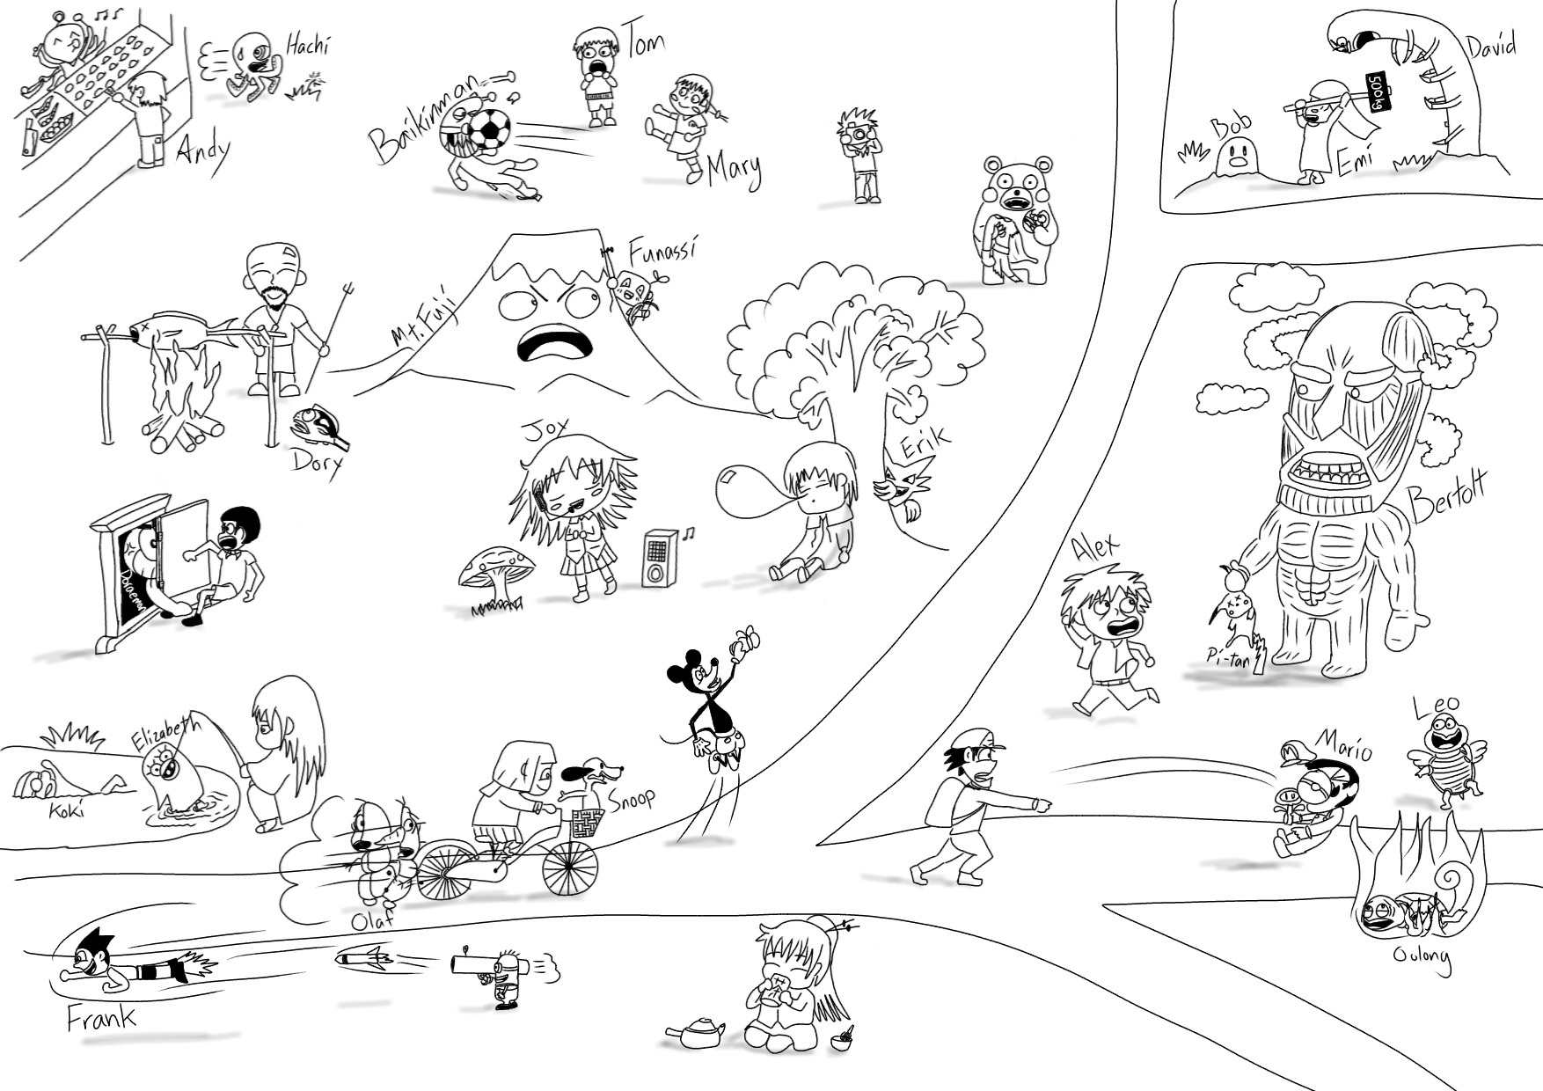
名前リスト
Becky
Dave
Goku
Julia
Kevin
Kuma-tan
Mackey
Matt
Mike
Nobuta
Peso
Sadaharu
Satoshi
Tom
Zura

11
10
9
8
5
6
7
4
3
2
1

He/She/It
動詞＋ｓ
cook | don't 動詞 | drink | eat | get | go fish | have | is
isn’t | jump | like | play | ride | sleep | take | throw

