Who is that boy/girl/man/woman/・・・?
めあて：
She/He is 名前. She/He 動詞 ~ .
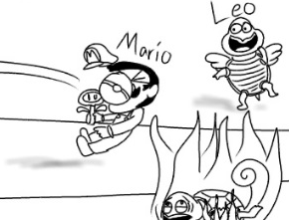
例：
Question | Who is that man with short black hair?
Answer | He is Mario.
+1文  ボーナス | He doesn’t like Pokémon.  例  He is short.  He has a flower.  He plays Pokemon.

1. Q | Who is that girl with long hair?
A

2. Q | Who is that boy with a cap?
A

3. Q | Who is that mouse with black ears? (mouse・ネズミ)(ears・耳)
A

4. Q | Who is that man with long hair?
A
Class:_____ Number:_______ Name:
5. Q | Who is that boy with a camera?
A

6. Q | Who is that man with no hair?
A

7. Q | Who is that girl on a bike?
A

8. Q | Who is that boy by the tree? (tree・木)
A

9. Q | Who is that bear with Anpanman?
A

10. Q | Who is that yellow character with a bazooka? (character・キャラクター)
A

11. Q | Who is that boy with Doraemon?
A

