 |  | 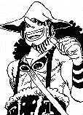 |  | 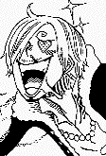 |  |  |  | 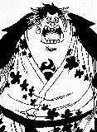 |  |  | 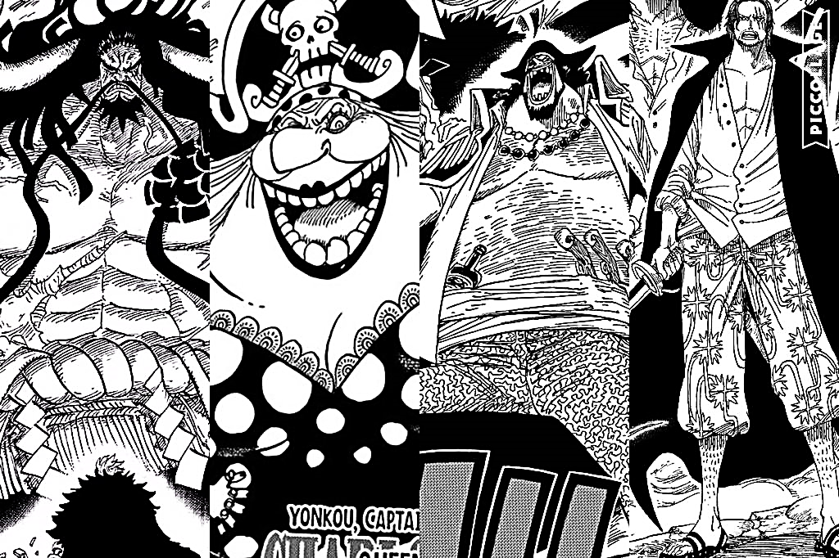 | 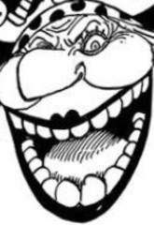 |  | 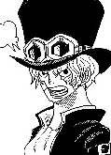  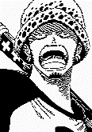 |  | 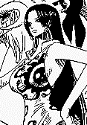 | 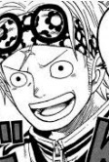 | 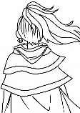 | 
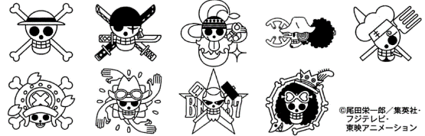  ○ | 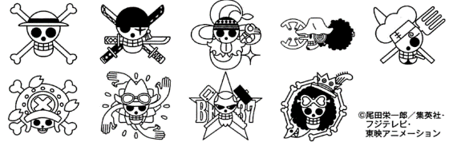  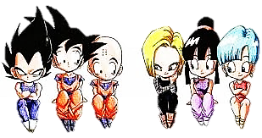  ○ | 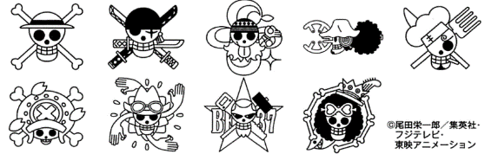  ○ | ○ | ○ | ○ | ○ | 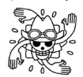  ○ | ○ |   ○ |     ○ | ○ |   ○ |   ○ |   ○ |   ○ |   ○ | ○ |  | ○

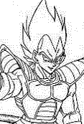
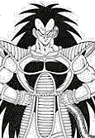
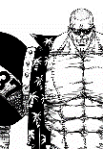


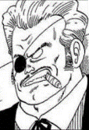

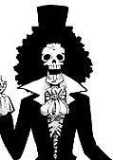
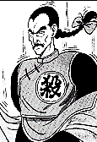
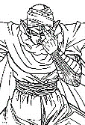
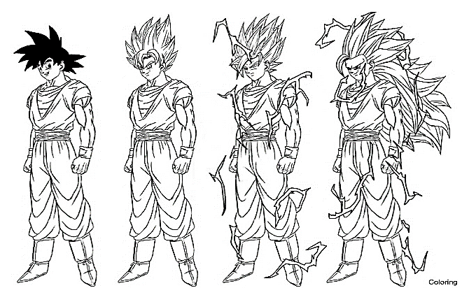



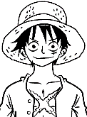
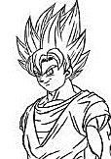 | 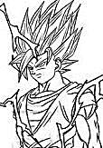 |  |    | 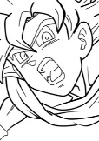 |  |  | 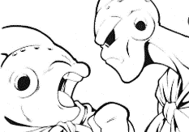 | 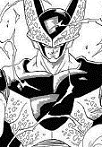 |  | 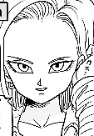 | 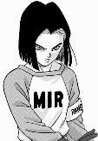 | 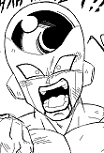  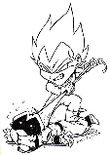 |  |  |  |  |  | 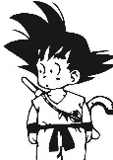
○ | ○ | ○ | ○ | ○ | ○ | ○ | ○ | ○ | ○ | ○ | ○ | ○ |  | ○ | ○ |   ○ | ○ | ○ | ○

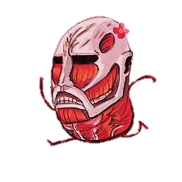
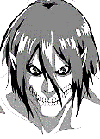
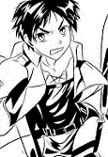
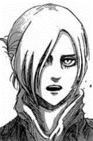
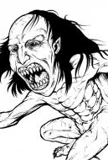
 |  | 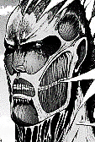 | 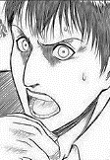 | 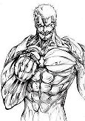  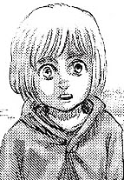 |  | 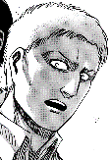 | 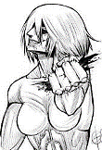 |  | 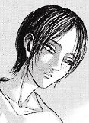 |  |    |  | 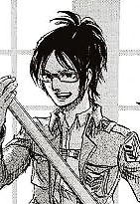   | 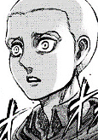 |  | 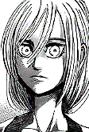 | 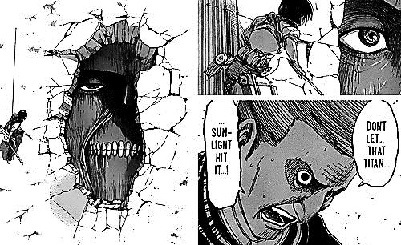   | 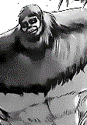  
○ | 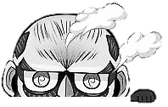  ○ | ○ |   ○ | ○ | ○ | 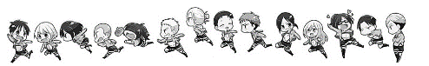  ○ | ○ | ○ | ○ | ○ | ○ | ○ | ○ | ○ | ○ | ○ | ○ | ○ | ○

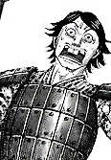

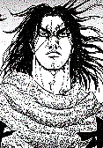
 |  | 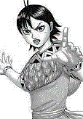 | 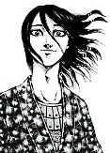  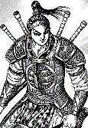 | 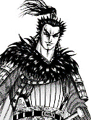 | 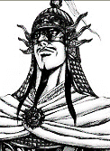 | 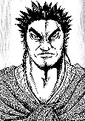 |  | 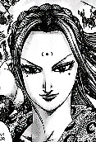 | 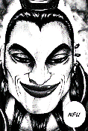 | 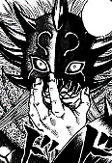 |  | 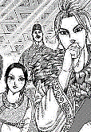  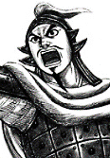 |  | 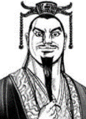 |  |  | 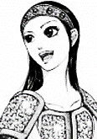 |  | 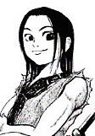
○ | 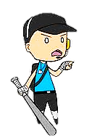  ○ |   ○ | 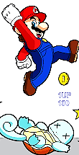  ○ |  | ○ | ○ | ○ | ○ | 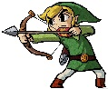  ○ |   ○ | ○ | ○ | ○ | ○ | ○ | ○ | ○ | ○ | ○

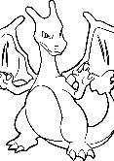
!
.
.
?
 | 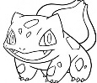   |  | 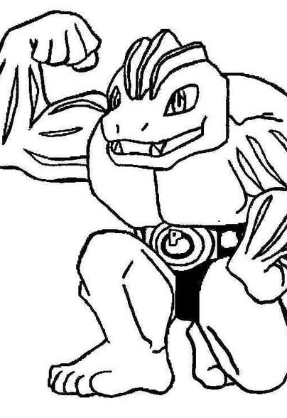 |  | 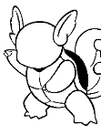 |  | 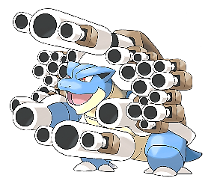 | 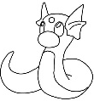 | 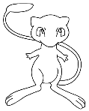   |  |  |  |  |  | 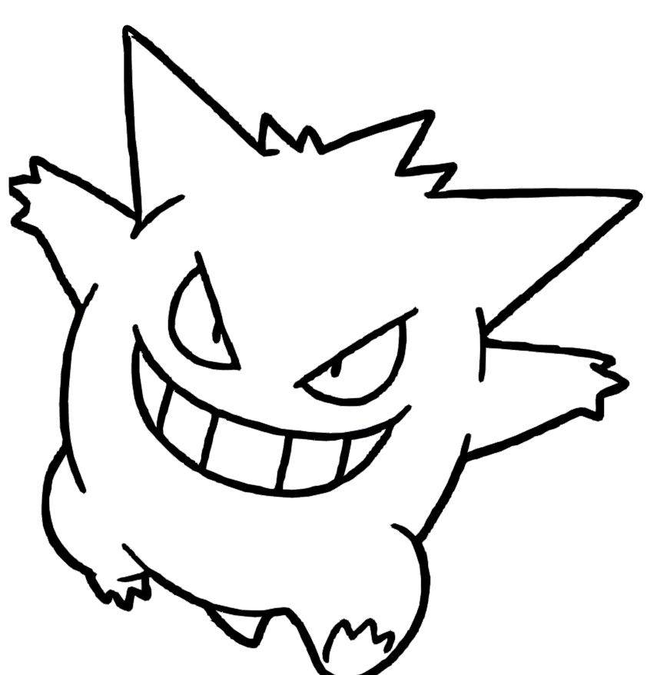 | 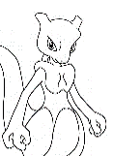 | 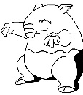 | 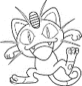
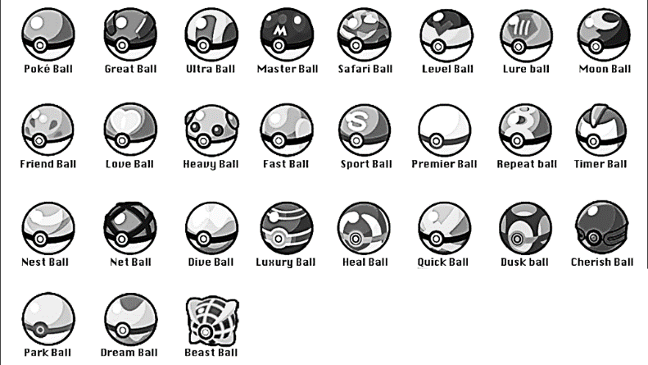 |  |  | 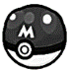 |  |  |  |  |  |  |  |  |  |  |  |  |  |  |  |     ○
 |  |  |  |  |  |  |  |  |  | 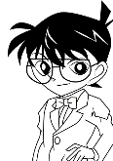 |  |  | 
○ | ○ |   ○ | ○ | ○ | 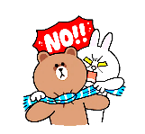  ○ | ○ | ○ | ○ |   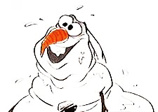 | ○ | ○ | ○ |   ○ | ○ |   ○ | ○ | ○ | ○ | ○
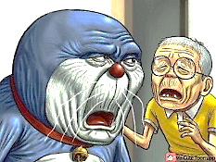





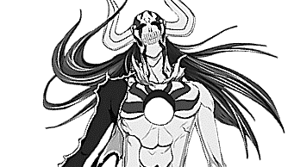



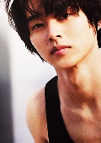
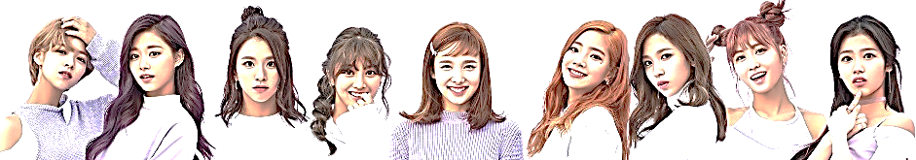
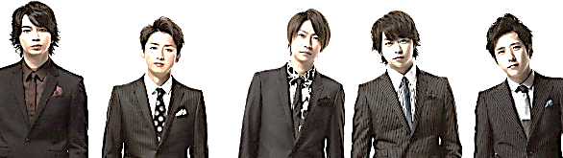
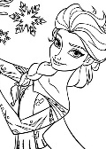
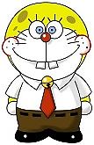 |  |      |   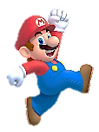  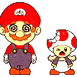 |  | 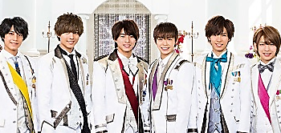  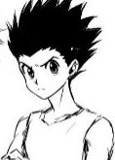 |  | . . |  | 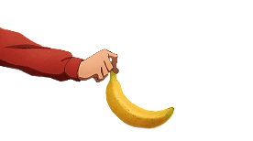 |  |  |  |  |  |  |  |  | 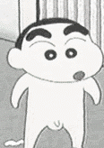
○ | 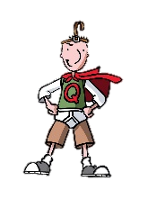  ○ | ○ | ○ | ○ | ○ | 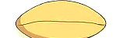  ○ | ○ | ○ | ○ | ○ |   ○ | ○ | ○ |   ○ | ○ | ○ |   ○ | 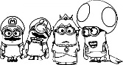  ○ | ○
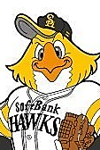

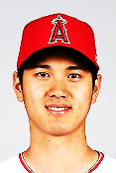





 |  |  |  | 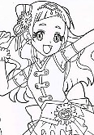 | 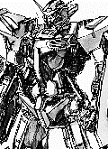 |  |  | 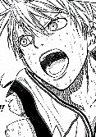 |  | 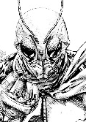 |   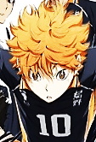 | 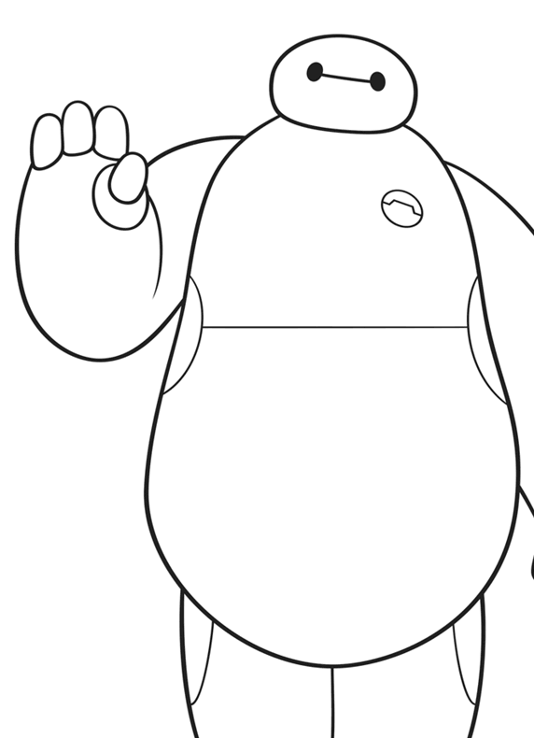 | 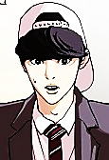 |  |  |  | 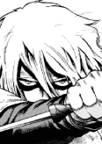 | 
○ | ○ | ○ | 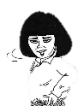  ○ | ○ | ○ | ○ | ○ | 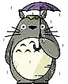 |   ○ | ○ | ○ | ○ | ○ | ○ | ○ | ○ | ○ | ○ | ○
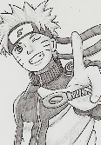

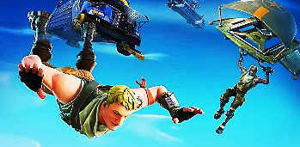
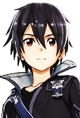
 | 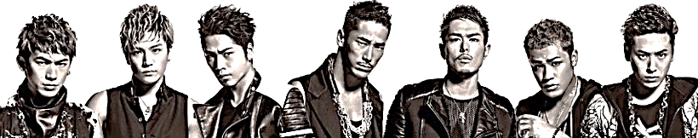 |  |  |  |  |  |  |  |  |  | 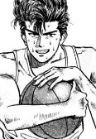 |  |  |    |  |  |  |  |   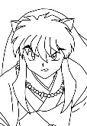 |  |  | 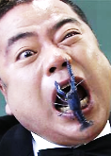   |  | 
  ○ | ○ | ○ |  |  | ○ |  | ○ | ○ |  | ○ | ○ |  |   ○ | ○ | 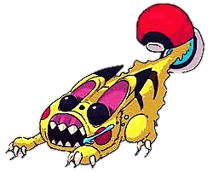  ○ |  |  | ○ | ○ |  | ○ | ○ |  | ○ | ○ |  | ○ | ○
10 stickers |  |  |  |  |  | 20 stickers |  |  | 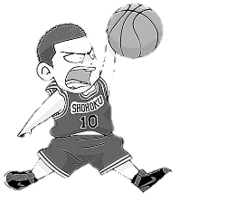 |  |  |  |  |  |  |  |  |  |  | 30 Stickers |  |  | 40 Stickers |  |  | 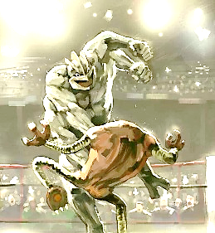  50 Stickers
Disney  K-On    Bleach  KARA  Toriko |  |  | Rirakuman  Kitty-chan  Shojojidai  Ansatsu Kyoshitsu  Hunter x Hunter |  |  | Naruto  Gintama  Fairy Tail    Mario |  | Reborn!  Inazuma Eleven  Hey Say Jump |  |  |  | 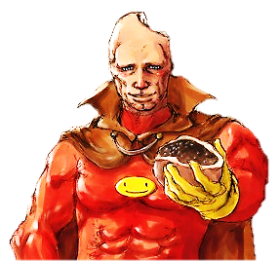    Kiss-my-ft2  Doraemon  Shin-chan |  |  |  |  |   SMAP |  |  |   One Piece  Kuroko no Basket  Monster Hunter  Dragon Ball |  |  | EXILE  J-Soul Brothers  3Daimei  Matt  ARASHI |  |  | Request
○ |  | ○ |  | ○ | ○ |  | ○ | ○ |  | ○ | ○ |  |  | ○ | ○ |  |  | ○ | ○ |  | ○ | ○ |  | ○ | ○ |  | ○ | ○


 |  |  |  |  |  |  |  |  | 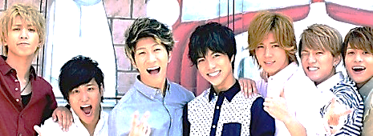 |  |  |  |  | 
○ | ○ | ○ | ○ | ○ | ○ | ○ | ○ | ○  . . | ○ | ○ | ○ | ○ | ○ |   ○ | ○ | ○ | ○ | ○ | ○
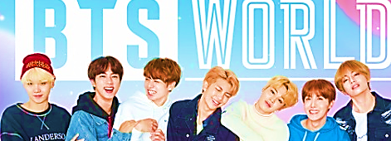
 |  |  |  |  |  |  |  |  |  |  |  |  |  |  |  | 
○ | ○ | ○ | ○ | ○ | ○ | ○ | ○ |  | ○ | ○ | ○ | ○ | ○ | ○ | ○ | ○ | ○ | ○ | ○
 |  |  |  |  |  |  |  |  |  |  |  |  |  |  |  |  |  |  | 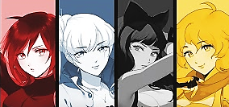
○ | ○ | ○ | ○ |   ○ | ○ | ○ | ○ | ○ | ○ | ○ | ○ | ○ | ○ | ○ | ○ |   ○ | ○ | ○ | ○


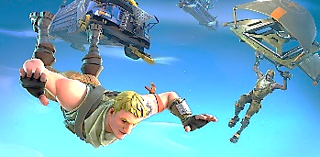
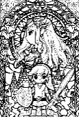
.
 | 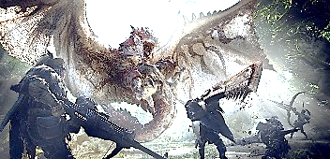 |  |  |  | 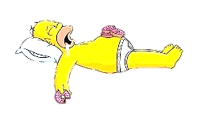 |  |  |  |  |  |  |  |  |  |  |  |  | 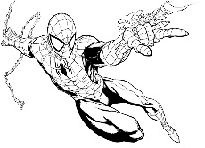
○ | ○ | ○ | ○ | ○ | ○ | ○ | ○ |   ○ | ○ | ○ | ○ | ○ | ○ | ○ | ○ | ○ | ○ | ○ | ○
This is 2 different version. Version 1, that I use is pages 1 and 2 printed front and back. Version 2 is pages 1 and 3. Page 2 has a list of prizes the students can “cash-in” their accumulated stickers to receive. The prices are small printed, laminated, and cut pictures. They’re time consuming to make, but the kids love them and once you have a large stock its fast to replenish.

This is a current 2019 version of the sticker sheet. However, I recommend you customize it yourself as some of the images used will become dated. Also hiding a picture of yourself somewhere in the sheet is fun for the kids.

Page 1 top to bottom
One piece
Dragonball
Attack on Titan (manga version)
Kingdom (manga version)
Pokemon

Page 2 left to right, top to bottom
Twice/Claire from Claymore/Elsa/Yamazaki Kento/Conan/Ikimono Gakari’s lead singer Yoshioka Kiyoe/Natsu from Fairy Tail/Justin Beaver/ARASHI
Doraemon as Spongebob/some dumb ALT/Mario/Hajime (youtube)/Gon Freaks/King and Prince/a banana from OPM/Old Doraemon/Hollow Kurosaki Ichigo/Kyarii Pamyu Pamyu/Musashi from Vagabond/Mizuhara Kiko/Rey/Shin-chan/Koro-sensei
Jam Oji-san/BTS/Cure Yell/Gundam/Taytay/Kuroko no Basket/Ohtani Shohei/Kamen Rider/Haikyuu/Masaki Suda/BeyMax/Daniel Park from Lookism/Kenshin Himura/Rapunzel/Watanabe Naomi/Thorfinn from Vinland Saga/Rola
Naruto/Sandaime J-Soul Brothers/Slam Dunk/Kiminawa/Ariana Grande/Kirito from SOA/Amuro Namie/Inuyasha/Urameshi Yusuke/Degawa Tetsuro/Fortnite

Page 3 left to right, top to bottom
Twice/Claire from Claymore/Elsa/Yamazaki Kento/Conan/Ikimono Gakari’s lead singer Yoshioka Kiyoe/Natsu from Fairy Tail/Justin Beaver/ARASHI
Doraemon as Spongebob/Kimetsu no Yaiba/Mario/Utada Hikaru/Gon Freaks/King and Prince/Jonnyy’s West/Hollow Kurosaki Ichigo/Kyarii Pamyu Pamyu/Musashi from Vagabond/Mizuhara Kiko/Rey/Shin-chan/Koro-sensei
Jam Oji-san/BTS/Cure Yell/Gundam/Taytay/Kuroko no Basket/Ohtani Shohei/Kamen Rider/Haikyuu/Masaki Suda/BeyMax/Daniel Park from Lookism/Kenshin Himura/Rapunzel/Watanabe Naomi/Thorfinn from Vinland Saga/Rola
Naruto/Sandaime J-Soul Brothers/Slam Dunk/Kiminawa/Ariana Grande/Kirito from SOA/Amuro Namie/Inuyasha/Urameshi Yusuke/Degawa Tetsuro/RWBY
Zelda/Monster Hunter/Homer Simpson/Old Doraemon/Tanukana (Tekken Esports)/a banana from OPM/Fortnite/Yonekura Ryoko/Deathnote/Kenny/Spidey/Hajime (youtube)

