Class 2-___ No:____ Name:
めあて：
 | subject | be verb | ing verb | what and when
 | Anpanman | was | punching | Baikinman at 9:00
 | Doraemon | was | training | this morning
 | Shohei | was | getting | Pikachu before the game.
 | Jam Ojisan was making Anpanman’s head before breakfast.
 | Luffy was eating and sleeping after fighting.
 | Imoto was running on Sunday.
 | Degawa was riding a bike on TV.
 | Saitama and Anpanman were fighting last night.
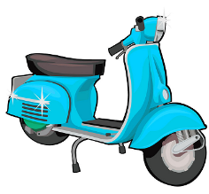
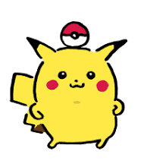
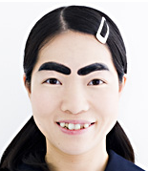
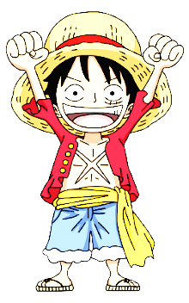
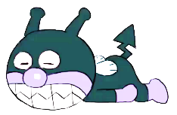
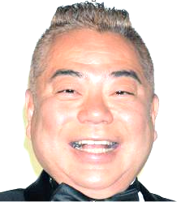
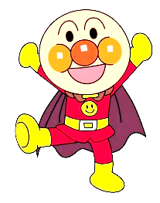
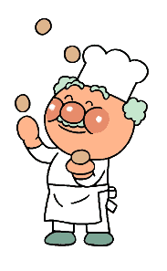
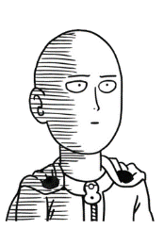
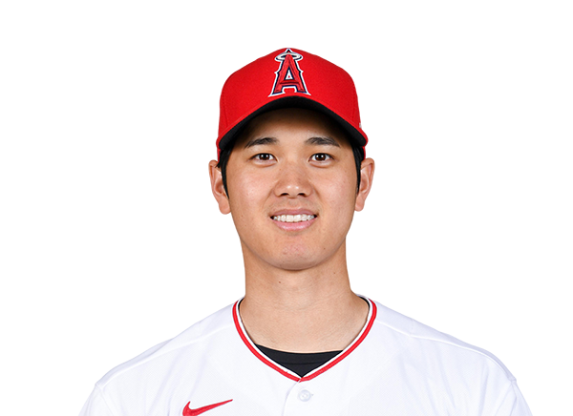
Imoto
scooter
monsterball
Pikachu
Luffy
Baikinman
Shohei
Anpanman
Jam Ojisan
Degawa
Saitama

