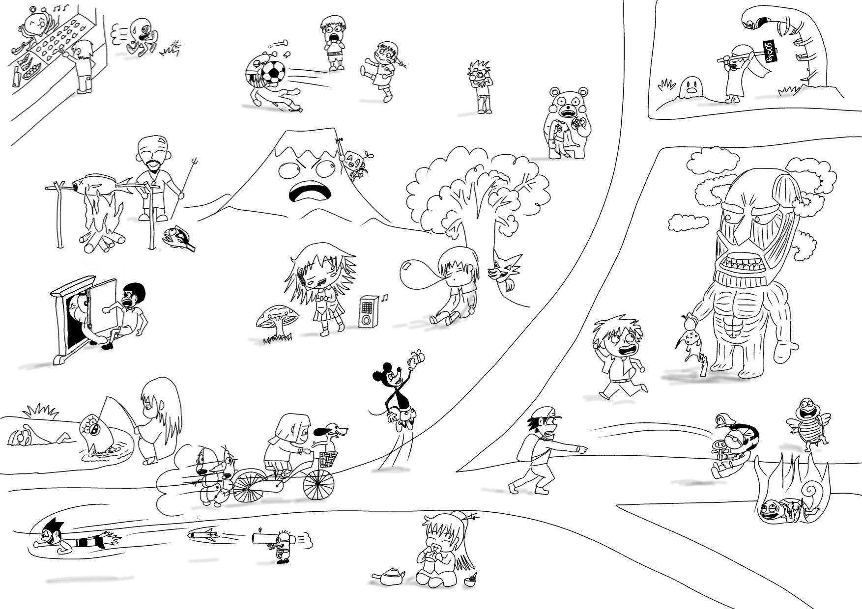
George
Sadaharu
Uirusuman
Don Pedro
Gen
Mary
John
Andy
Bobby
Uirusuman
Gen
Tom
An-chan
Fred
Mike
Mary
John
Alex
Pi-tan
Bertolt
Jim
Becky
Degawa
An-chan
Fred
Julia
Dave
Sotashi
Moria
Alex
Pi-tan
Peter
Bertolt
Lily
Astro
Kevin
Julia
Dave
Sotashi
Moria
Peter
Mockey
Astro
Kevin
Noopy
Yukiman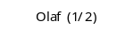
Nemo
Elizabeth
Zura
Lily
Yukiman
Fruity-man
Sadaharu
Don Pedro
Nibota
Nemo
Elizabeth
Nise-emon
Noopy
Fruity-man
Ben
Arianna
Gen
Tom
Mockey
Julia
Mike
Bobby
Andy
Arianna
George
Ben
Gen
Tom
Nibota
Nemo
Elizabeth
Zura
Jim
Becky
Degawa
Nise-emon
Master Copy
George
Fruity-man
Sadaharu
Uirusuman
Don Pedro
Ben
Arianna
Nibota
Astro
Kevin
Gen
Tom
Mockey
Noopy
Yukiman
Nemo
Elizabeth
Zura
Lily
Julia
Dave
Sotashi
Moria
Alex
Pi-tan
Peter
Bertolt
Jim
Becky
Degawa
An-chan
Fred
Mike
Mary
John
Andy
Bobby
Nise-emon

