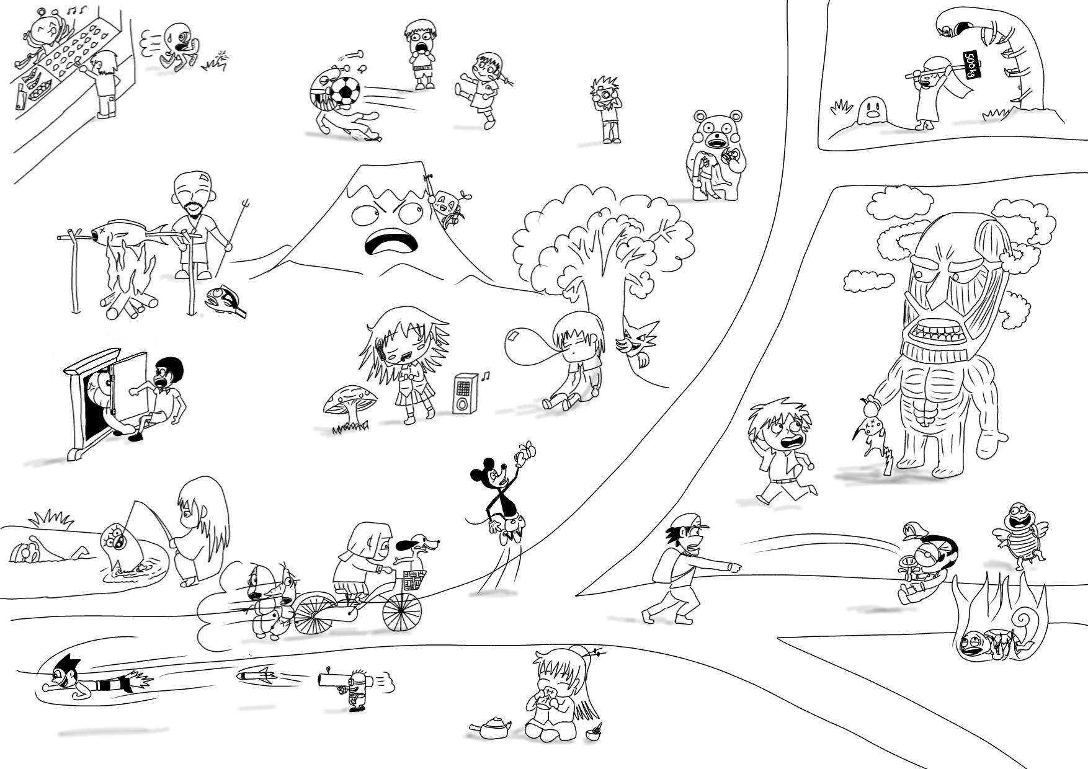
George
Fruity-man
Sadaharu
Uirusuman
Don Pedro
Ben
Arianna
Nibota
Astro
Kevin
Gen
Tom
Mockey
Noopy
Yukiman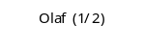
Nemo
Elizabeth
Zura
Lily
Julia
Dave
Sotashi
Moria
Alex
Pi-tan
Peter
Bertolt
Jim
Becky
Degawa
An-chan
Fred
Mike
Mary
John
Andy
Bobby
Nise-emon

